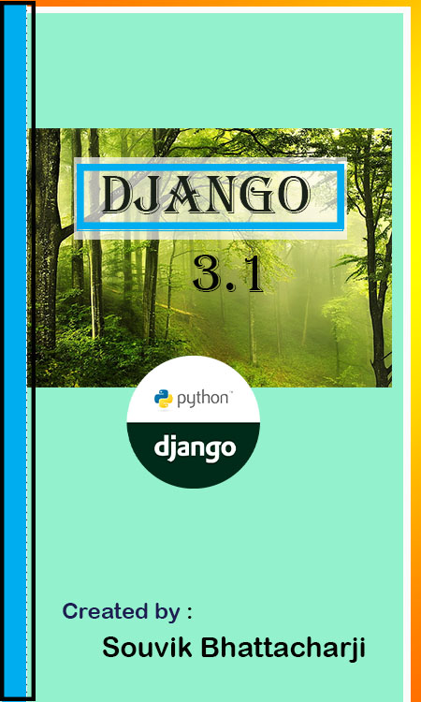

Introduction to Django

Creating Django project

**Pip installing into windows**

To install Django into the window platform you need to install Pip into the system for that.

First type the command into the command prompt:

c:\> pip3 install django==2.0.9

After installing the django we need to check the version of the django version or not. For that you need to type:

c:\>django-admin.py version